

User Guide

|  |  |
| --- | --- |
| NAME | ID |
| Tamim Alhussain | 215110441 |
| Abdulaziz Abuhamid | 216210568 |
| Mohammed Abdulal | 215110073 |
| Mohammed Allulu | 215110135 |
| Ahmad Alblaihed | 216110526 |
| MHD. Makeen AlDamouni | 215110141 |

# WHAT IS GITHUB?

**EXECUTIVE SUMMARY**

GitHub is a web-based version control code repository that seamlessly integrates with Git and allows developers around the world to easily collaborate on development projects.

# WHY DOES GITHUB MATTER?

As of April 2017, GitHub reported having over 26 million users and 57 million repositories, making it the single largest host of source code in the world.Who does GitHub

affect? GitHub affects developers of all types--from open source to proprietary and individuals to enterprise-level teams.

# WHO DOES GITHUB AFFECT?

GitHub affects developers of all types--from open source to proprietary and individuals to enterprise-level teams.

# WHEN IS GITHUB HAPPENING?

Initial development began on GitHub in November 2007. GitHub was founded February 8, 2008 and launched April 10, 2008.

# HOW DO I START USING GITHUB?

Sign up for an account, install the necessary tools, create a repository and a branch, and start editing/collaborating on your code.

To understand GitHub, you must first learn about Git, the command-line tool that was started by Linux creator Linus Torvalds to serve as a version control system for the Linux kernel. Git was originally developed in 2005 to replace BitKeeper. The Linux kernel community is vast, and maintaining commits to the kernel would be a massive challenge without a reliable version control system--hence, the need for Git. Since its creation, Git has perfectly served the Linux kernel community.

**WHAT IS GITHUB?**

But the development community also needed a way to easily collaborate on projects and network with peers, and that is where GitHub comes in. GitHub brings Git to the web, which in turn brings it to everyone. With a GitHub account, you can submit your projects either by using the git command on Linux or by using the GitHub Desktop application on Windows and Mac. With either tool you can check out projects, work on them, and commit your changes for review.

## GitHub's features include:

seamless code review.

small and large team collaboration. project management.

integrated issue and bug tracking.

graphical representation of branches (an environment where you can try out new ideas).

99.69% git uptime (as reported in 2016). enterprise accounts.

Although GitHub is the place for open source developers to collaborate on projects, closed-source developers worldwide use GitHub, too. In fact, companies including Google, Adobe, Twitter, Microsoft, and PayPal, as well as various government agencies in Australia, Argentina, Belgium, Canada, Finland, France, the US, and many more countries, use GitHub to great success.

One of the biggest success stories on GitHub is the Linux Kernel Community. As of this writing, the Linux kernel has over 670,000 commits, over 43,000 stars, and over 16,000 forks.

In the modern age of Software as a Service (SaaS) and mobile devices, app development must progress rapidly. Thanks to the likes of GitHub, quick and painless app development is a reality, and that has resulted in a significant reliance on version control tools like Git and GitHub; in fact, GitHub is the largest community of open source developers in the world--with millions of projects currently in development.

**WHY DOES GITHUB MATTER?**

Consider this: GitHub serves the needs of some very large projects, including: Reddit

Facebook Bootstrap Node.js

Ruby on Rails React Javascript Swift

Many development projects would never get off the ground without the ability to collaborate. And since collaboration doesn't always happen in the same geolocation, developers need the tools to enable the ability to work with their peers on projects--that is where GitHub comes into play.

## Additional resources:

GitHub awards researcher $18,000 for remote code execution flaw discovery (ZDNet)

Ex-Facebook engineers launch Honeycomb, a new tool for your debugging nightmares (TechRepublic)

Why the earliest open source licenses are still the most relevant (TechRepublic) The five biggest headaches for software developers (TechRepublic)

What are the highest paid jobs in programming? The top earning languages in 2017 (TechRepublic)

The most obvious people to benefit from GitHub is developers. With the help of GitHub, developers gain all the benefits of a centralized version control system. Projects are stored in repositories in such a way that developers can push and pull their changes to and from the project. Commits are reviewed and, if acceptable, merged. There is no more efficient way to work on a development project.

**WHO DOES GITHUB AFFECT?**

As a side effect of that efficiency, businesses benefit by way of faster software development. And because code is peer reviewed in GitHub, that software should be (in theory) more reliable, which benefits end users.

Open source projects are deeply affected by GitHub. The code repository helps attract developers to more open source projects, and it makes project management much easier.

## Additional resources:

How to become a developer: A cheat sheet (TechRepublic)

Why GitHub wants to get involved in Australia's innovation ecosystem (ZDNet) Job description: Mobile application developer (Tech Pro Research)

Job description: DevOps engineer (Tech Pro Research)

Microsoft joining the Linux Foundation comes down to one word: Cloud (TechRepublic) Apple is doubling down on open source (TechRepublic)

3 Linux Foundation networking projects that your business needs to know (TechRepublic)

Arduino: The smart person's guide (TechRepublic)

GitHub development began on October 1, 2007 and was quickly released as a beta (written in Ruby). In April 2008, GitHub officially launched, with Tom Preston-Werner, Chris Wanstrath, and PJ Hyett at the helm.

**WHEN IS GITHUB HAPPENING?**

On February 24, 2009, a team of GitHub members announced that GitHub had already accumulated over 46,000 public repositories. By July 5, 2009, GitHub was being used by over 100,000 developers and had grown to over 90,000 public repositories. On June 2, 2011, it was announced that GitHub surpassed SourceForge and Google Code in number of commits (for the period of January-May 2011). In 2016, GitHub made the Forbes Cloud 100 list, ranking 14.

As of 2017, GitHub employees 598 people and has over 26 million users.

In June, 2018, Microsoft acquired GitHub. Considering Microsoft has been one of the biggest contributors to GitHub, this should come as no surprise (Microsoft even hosts its original file manager on GitHub). There has been some concern within the open source community as to what this will mean to GitHub going forward. One thing has been made clear: Many developers have begun migrating from GitHub to GitLab, because of the Microsoft purchase--GitLab is reporting 10 times the normal usage since the announcement.

## Additional resources:

Microsoft buys GitHub for $7.5 billion (ZDNet)

Why Microsoft is buying GitHub: It's all about developer relationships (ZDNet)

If Microsoft buying GitHub freaks you out, here are your best alternatives (TechRepublic)

With GitHub acquisition, Microsoft wants to make Azure the default cloud for developers (TechRepublic)

Will Microsoft buying GitHub change the future of apps? (Download.com) GitHub rolls out new business option (ZDNet)

Linux Foundation chief: Businesses that don't use open source 'will fail' (TechRepublic)

GitHub is not alone in the version control/developer collaboration business. Its competitors include:

**WHO ARE GITHUB'S COMPETITORS?**

CollabNet Subversion Vault Perforce Helix

Team Foundation Server BitKeeper

GitLab

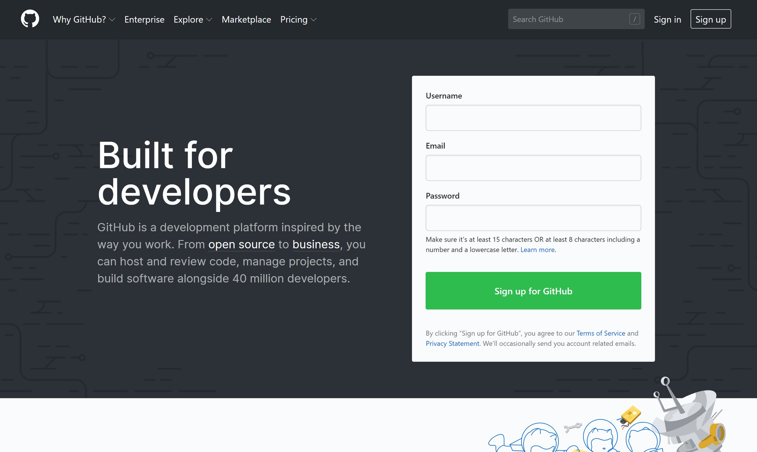First, sign up for a GitHub account. Then, you should either install the command tool git on your Linux desktop or install the GitHub Desktop client on your Windows or Mac machine.

**HOW DO I START USING GITHUB?**

With the tools in place, follow the standard steps for using GitHub.

1. Create a local git repository.
2. Add a new file to the repository.
3. Add a file to the staging environment.
4. Create a commit.
5. Create a new branch.
6. Create a new repository on GitHub.
7. Push a branch to GitHub.
8. Create a pull request.
9. Merge a pull request.
10. Get changes on GitHub back to your computer.

Once you get the hang of the process, you'll be submitting projects and collaborating on code like a pro.